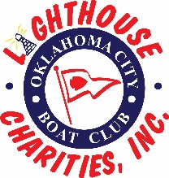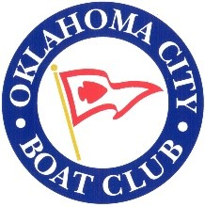

Lighthouse Charities, Inc.

Oklahoma City Boat Club (OCBC) formed Lighthouse Charities, Inc. ("LCI") in 2001 to provide charitable activities to the Oklahoma City community. It is a tax deductible 501(c)(3) public charity. During its first 10 years, it distributed most of the annual regatta proceeds to other 501(c)(3) organizations in the greater Oklahoma City community. For the last 10 or more years, LCI has provided scholarships for underserved children in the OKC community to attend one or more week-long summer youth sailing camps held at OCBC.

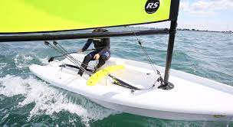
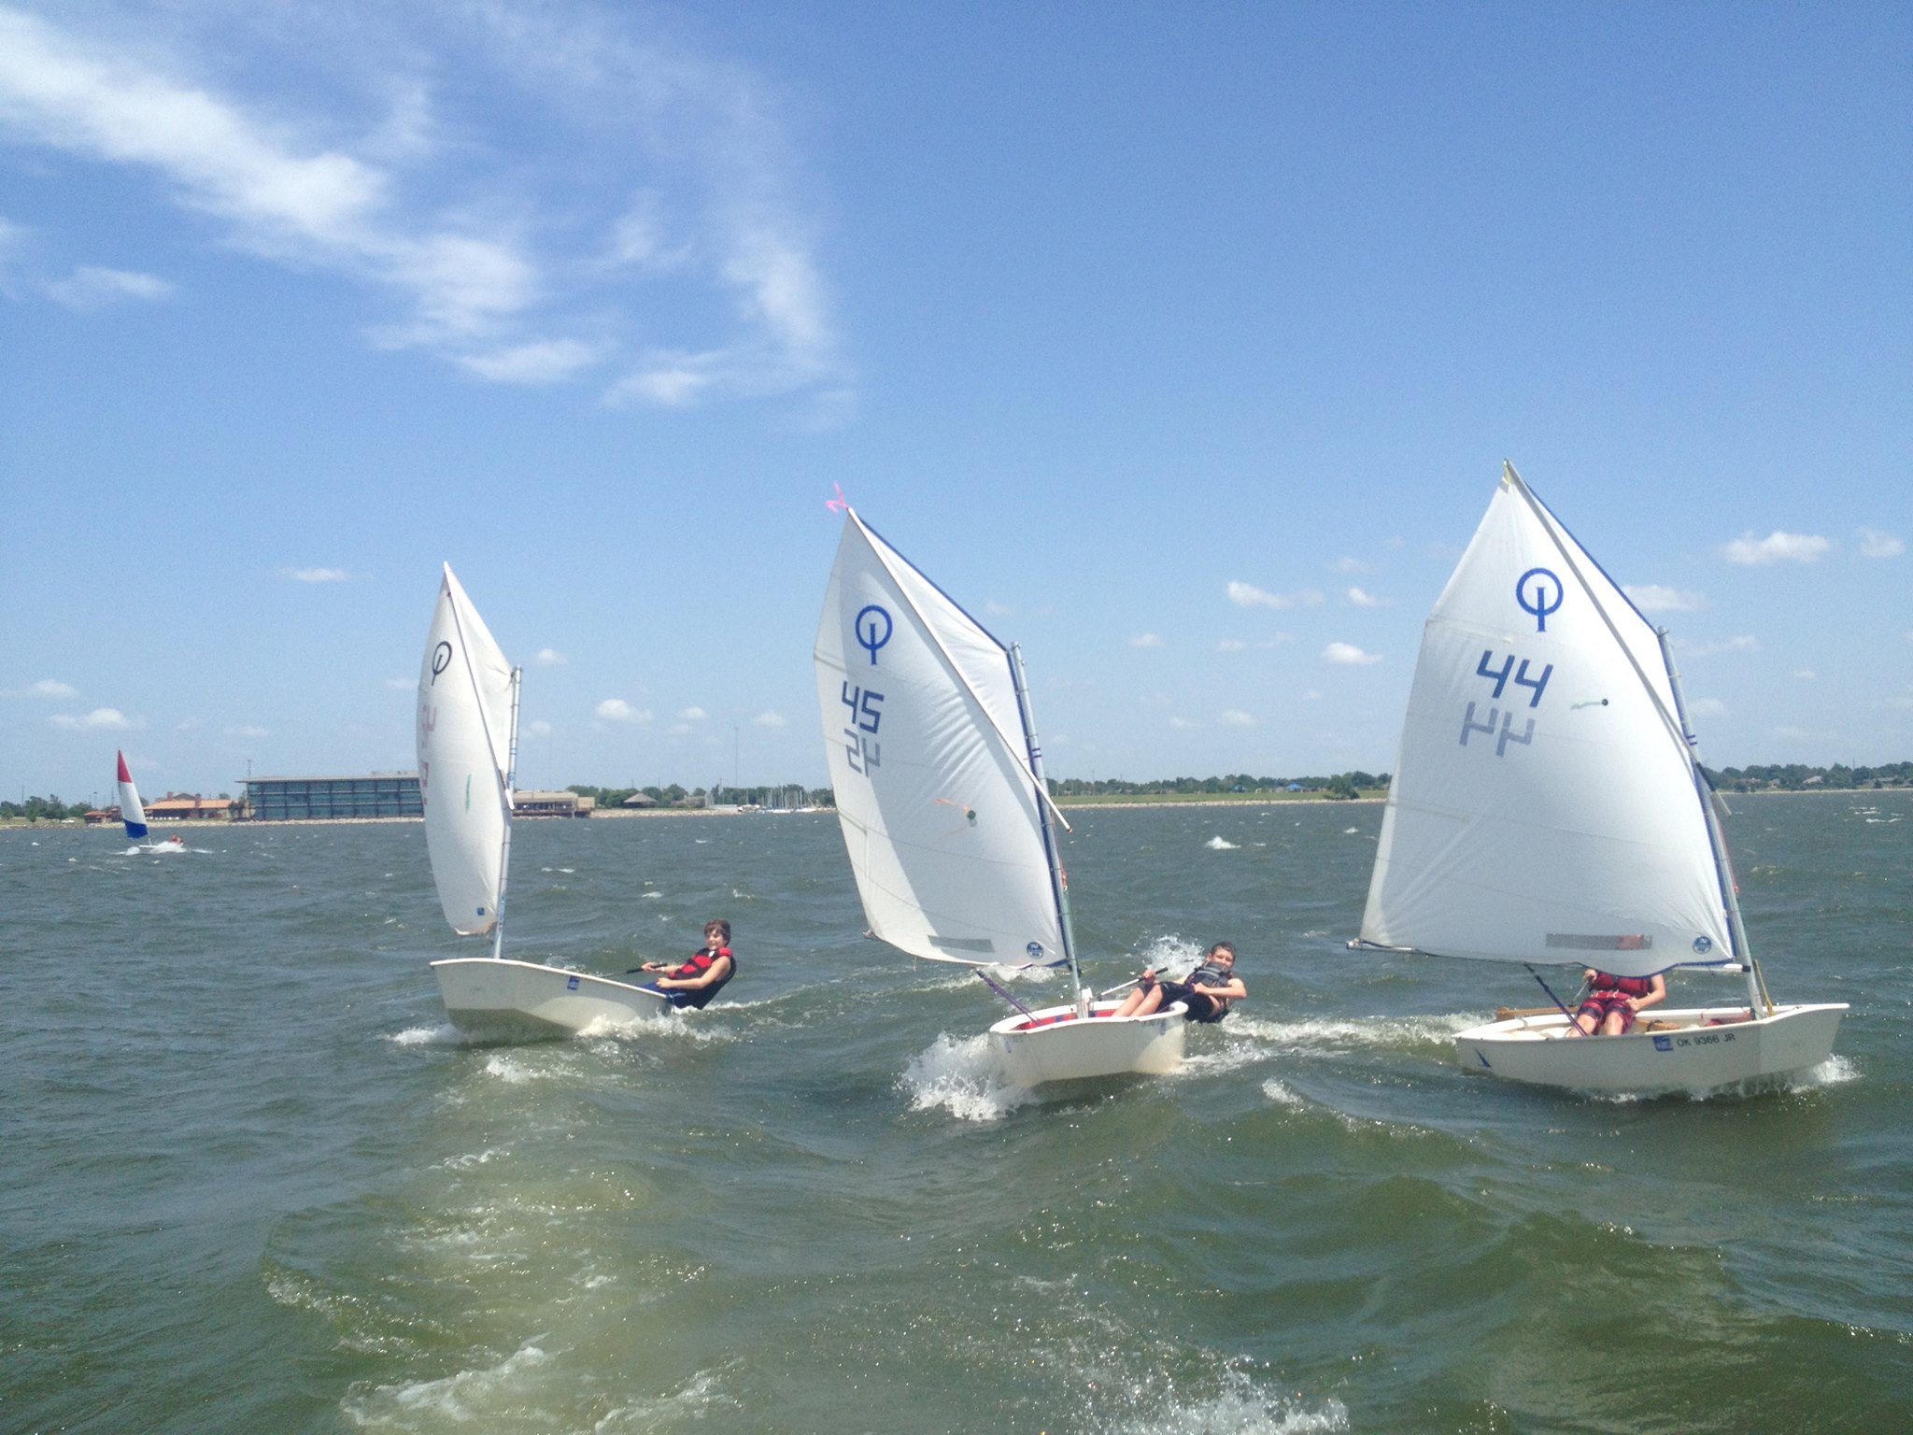
Little Light Christian School, Boys and Girls Club, Peppers Ranch and Single Parent Support Network were some of the organizations awarded scholarships in 2019 to sponsor children in their programs. In 2020 and 2021, attendance was lower due to COVID-19. The camp also provides children incentives to learn to swim, as it is a requirement to participate in the sailing camps.
The sailing camp is open to the public and available to children interested in learning to sail whether or not their family belongs to OCBC. More adult lessons are available than last year. In 2021, LCI purchased 10 new RS Zest dinghies to replace our Pico fleet for training boats.

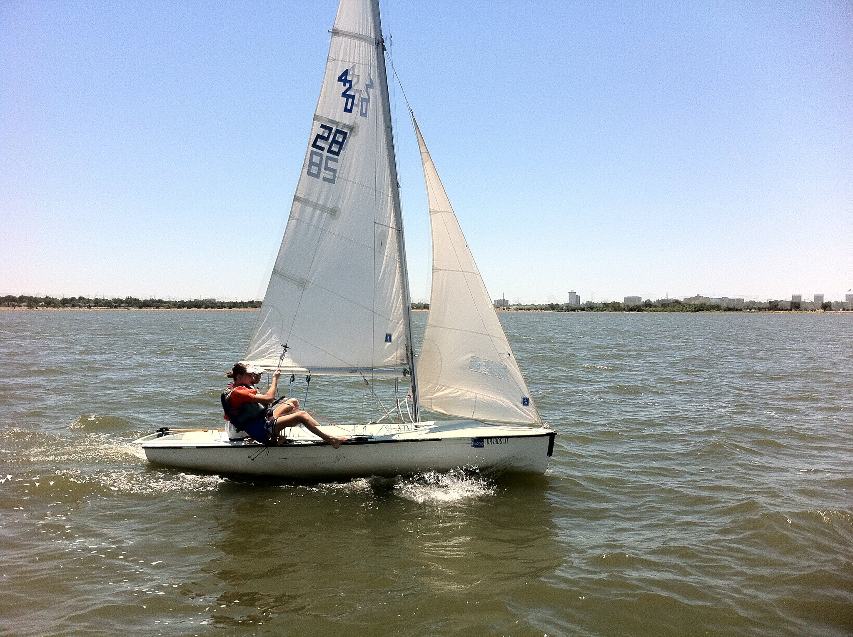
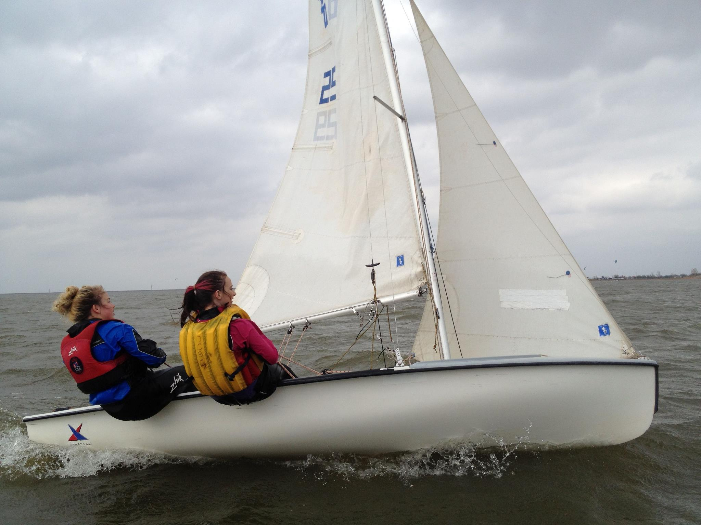

LCI is volunteer-run, with The only paid employees being the youth sailing coaches and instructors who run the summer camps during June, July and August. Registration for the summer camps, adult lessons and other information about can be found on LCI's website at www.okclighthouse.org.
Adult volunteers are needed to assist during the sailing camps.

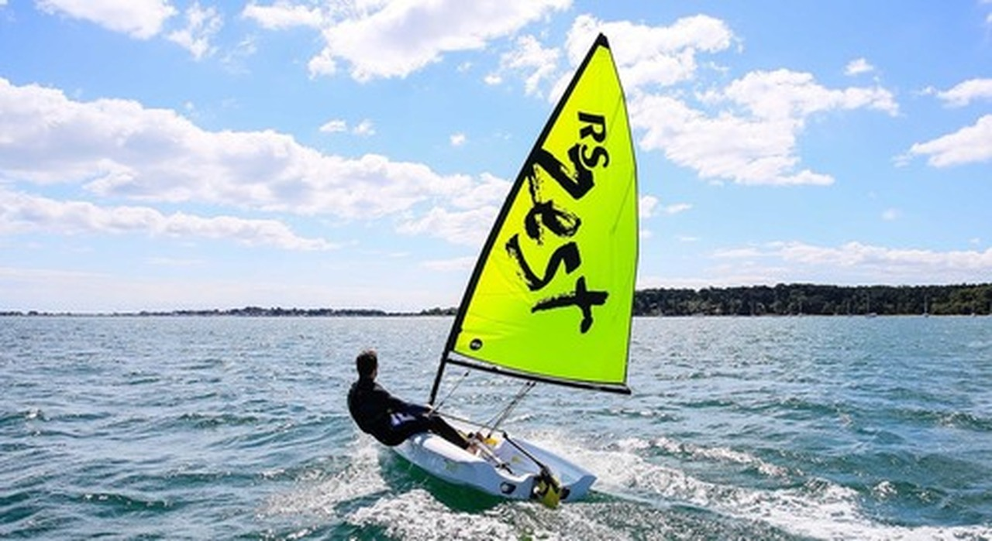

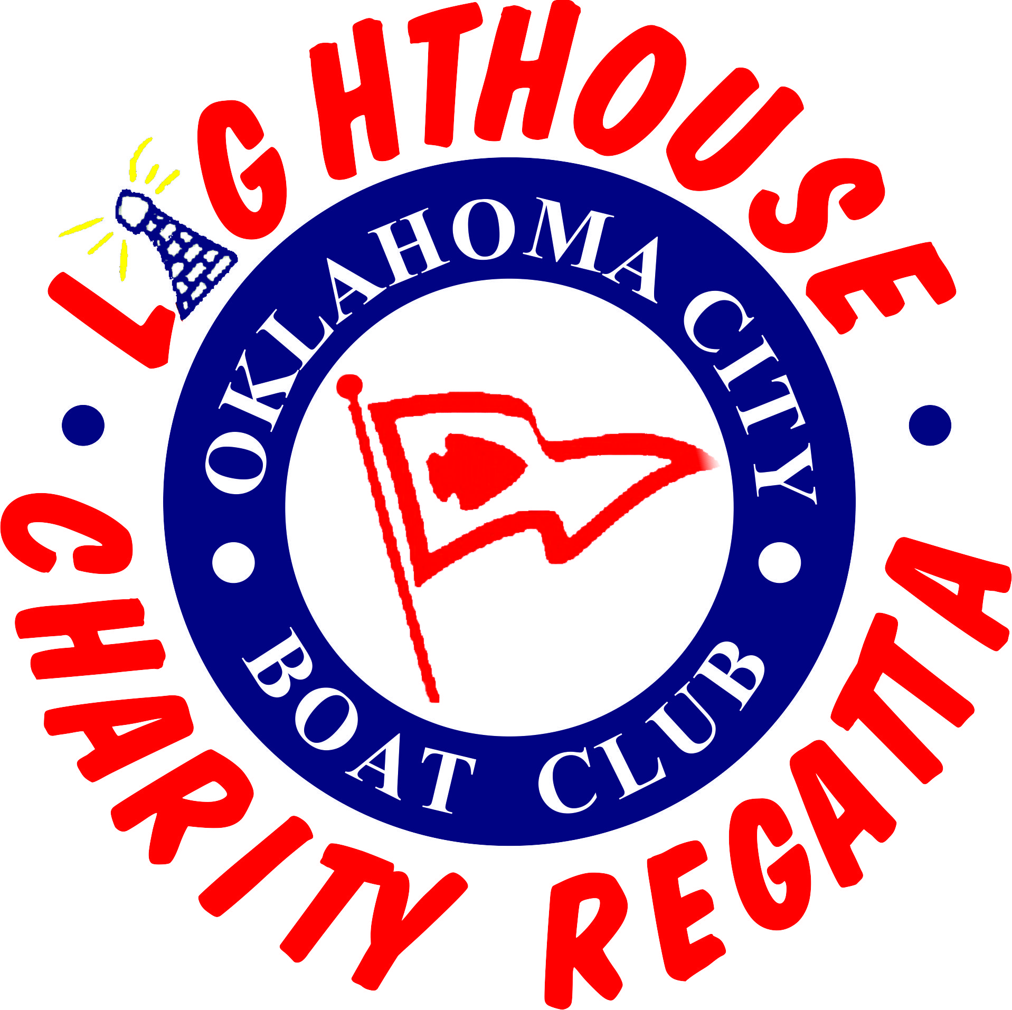
As set forth in LCI’s Certificate of Incorporation, its purposes are exclusively for educational or charitable purposes, including: (a) to award need-based scholarship, grant, and/or other forms of financial support to sailors of all ages and skill levels to participate in sailing-related activities and/or programs; (b) to promote and present sailing regattas and/or other sailing-related activities to advance community participation in the Corporation’s charitable fundraising, giving and educational efforts and programs; (c) to support and provide sailing programs, sailing activities and opportunities to learn, volunteer and connect with the local sailing community that are accessible to the general public; (d) to conduct youth sailing programs and activities accessible to youth in the community as one method of combating juvenile delinquency; (e) to mentor potential candidates to participate in regional, national, international and/or Olympic competition.
OCBC has hosted many prestigious regattas including regional and national championships which are listed on its website. In 2008 alone, LCI co-hosted the Catalina 25 National Championship, Flying Scot Wife-Husband Championship, San Juan 21 North American Championship and Adams Cup U.S. Women’s National Championship. LCI has also hosted the Santana 20 Nationals in 2011, Catalina 22 Nationals in 2019, and the VX One North American Championship in 2021.
We were planning to host the U. S. Junior Women’s Doublehanded Championship (“Ida Lewis”) in July, 2020 that was cancelled by U.S. Sailing for 2020 and 2021. Between the 2 weekends of the 2023 annual Lighthouse Charity Regatta, the Hobie 20 National Championship will home-base at OCBC and sail on Lake Hefner.
Other than monies raised for national championship regattas, most LCI funding is raised from the proceeds of the Lighthouse Charity Regatta, LCI's annual benefit regatta. The 2023 Regatta will be held on June 17-18 (Centerboards & Multi-Hulls) and June 24-25 (Keelboats). There will be a dinner each Saturday night with tickets available to purchase. Saturday, June 24 will be catered by Hefner Grill followed by entertainment by a DJ.
There are several ways to contribute, including cash donations, in-kind donations, and regatta participation either as an individual or a sponsored team. See the Donor Agreement attached or on-line. LCI provides a letter documenting your tax deductible contribution. See Lighthouse Charity Regatta Registration on-line.
The new facility for the youth/LCI and centerboard sailing program is now finished. Please consider making a donation for the building, new Zest fleet of boats or ongoing programs.
Registration for the summer camps, adult lessons and other information about LCI and the annual charity regatta can be found on LCI's website at www.okclighthouse.org.

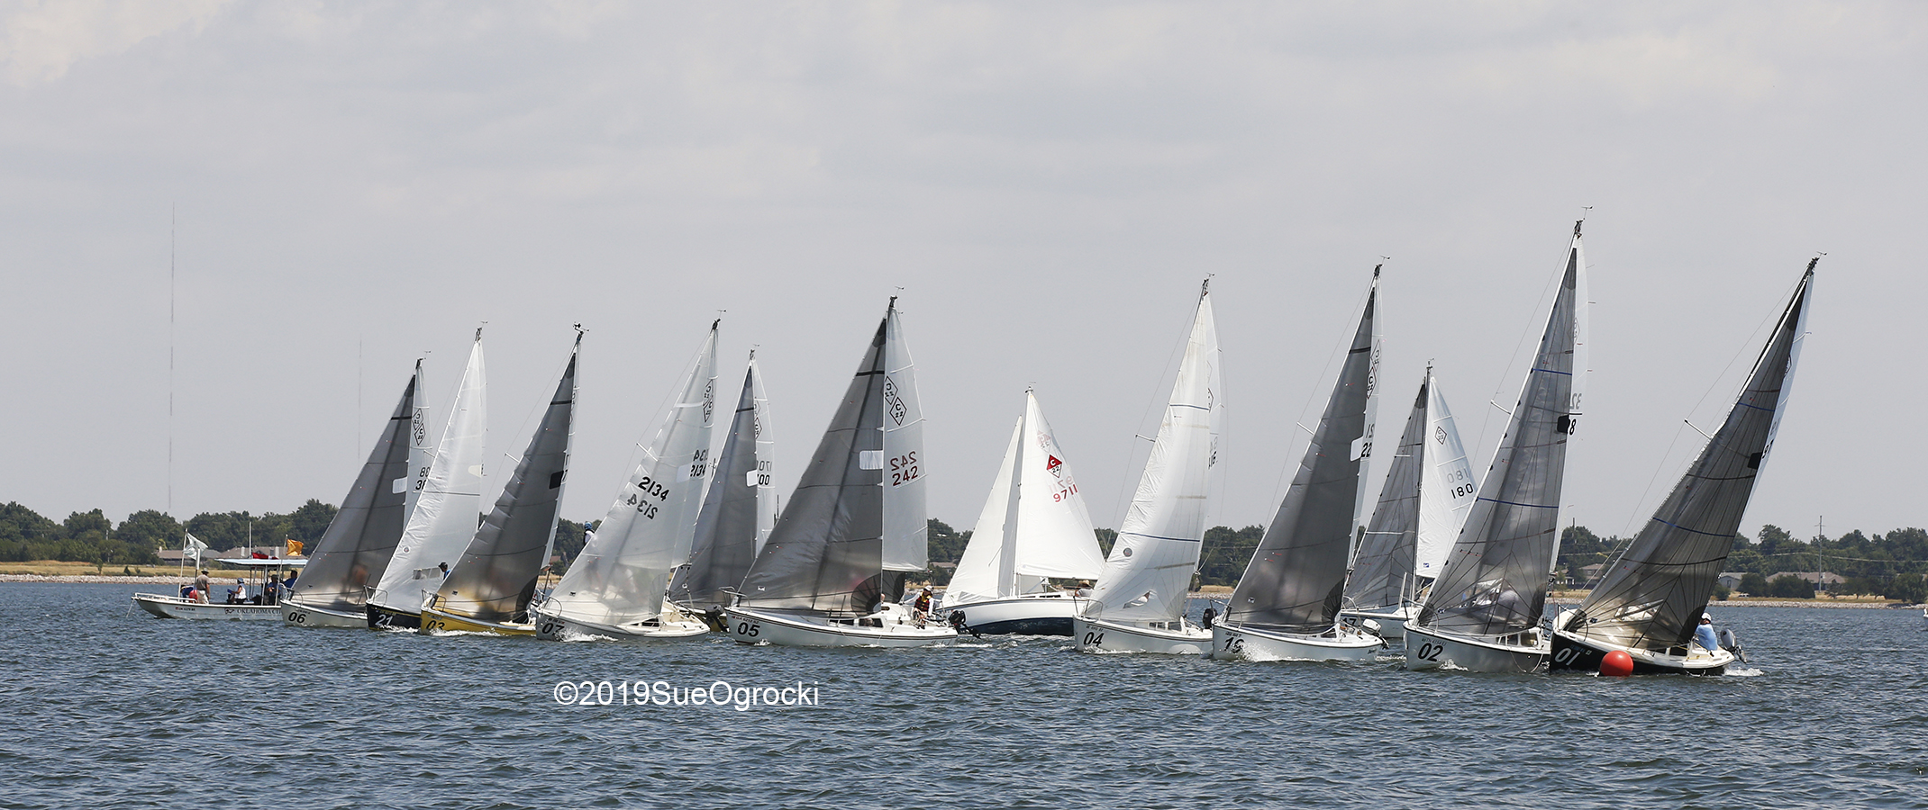

After the races each Saturday, there will be dinner for which tickets can be purchased for 6/17 at $25 each and for 6/24 at $40 each which includes DJ as entertainment. After the races each Sunday, there will be light refreshments (delicious leftovers!), presentation of the trophies to the winning teams Tickets for dinners (6/17 & 6/24) and T-shirts will be available for sale in June and may be pre-ordered online (must be pre-ordered for XXL and XXXL). T-shirts will include names/logos of donors on the back (for donors $500 and above) and the Event Board will include donors $250 and above.

This is a wonderful opportunity to learn how much fun sailing can be while participating in a regatta that serves a good cause. It can also be a good team experience.
For more information, please contact Justin Howard at 405-508-9951 or board3@okcboatclub.com, or Brian Wiesener at 832-499-3001or treasurer-elect@okcboatclub.com.

